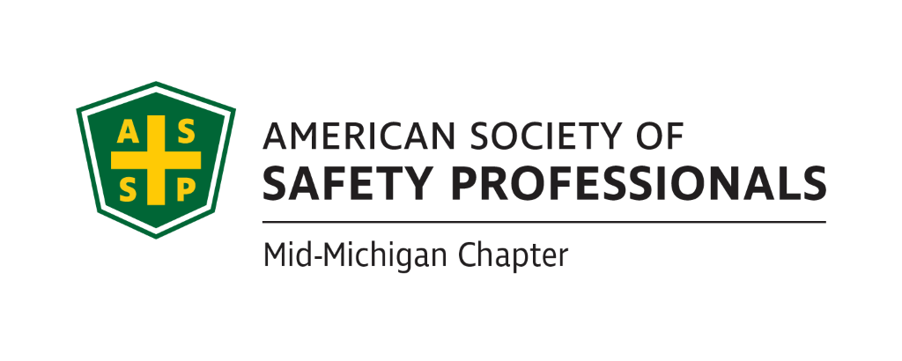
August Secretary Report
Meeting Date: August 17th, 2022
Meeting Time: 2:30-4:00pm
Format: WebEx
Attendees: Bob Schneider, Jeff Gray, Mary Bainbridge
Meeting started: 2:30pm
Meeting Ended: 3:45
July Secretary Report Review:
Will be reviewed in the future or next meeting
July Treasury Report Review:
Will be reviewed in the future or next meeting
Items from prior meeting:
- The ASSP swag Bob requested was received
- Carl is checking with Okemos hotel to check for pricing for future events.
- Craig reports that Sept 29th for Historical Museum for Contractor Safety presentation-parking is $5. What time 9 or 10am?
  - Bob will send out parking map when the announcement goes out for the presentation.
- Jeff recommended having a “save the date” for Contractor Safety presentation to hand out at coffee with MIOSHA. The flyer should send them to our website for more info.
- Monthly website review-Bob loaded new photos on the website
- Bob also had Chapter Services update the website to include the Alliance signing.
- Financial audit scheduled for next meeting
- Meeting in person-do we want to schedule periodically? Quarterly? Let’s discuss at next meeting.
- Let’s look if September is available at LASC-Mary to check
- Chapterwise Mary to present for next meeting how we can get more points.

Past Chapter Events and activities:

- Nothing to report here

Future Chapter Event updates:
- TBD: “Multi-Employer Worksite & Managing Contractors” –. Zach Hansmann
  - Will serve coffee and donuts.
  - Schedule around 12-1:30pm timeframe.
  - Craig sent Historical Museum dates of interest but hasn’t heard back yet, will follow up with a phone call.
- TBD: “Organizational Awareness” – Mike Snyder
  - No updates on this from last meeting.
  - Jeff talked with Great Lakes Safety Training Center and they are willing to allow us to use their facility for presentations. They are currently presenting some lockout/tagout training for which they have a grant, but that training may be too long. We will need to determine their availability based on their schedule. Jeff-will discuss next week and look to schedule in the fall.

- TBD: “Risk Management” (Jeff’s past presentation)
  - We need to determine when we can get this scheduled based on location availability and availability of the other presenter. Jeff can schedule in Sept or Nov. Could combine with Behavior Based Safety with Kelly, see below. GLST can host.
  - Possibility of combining “Drones” -see below, with this presentation as it ties in with Risk management.
  - Can we hold this at LASC or the Historical Museum or the Best Western if we decide to charge and provide CEUs for this event?
- TBD: “Behavior-Based Systems” –
  - We can use GLST.
  - No word on whether Kelly is available post retirement, Bob K will follow up before the next meeting.
- TBD: Tour of Michigan Sugar – Jeff
  - Just need to pick a date and book it, Jeff can reserve online from their website.
  - October 27th placeholder date until we hear back from the Board

- TBD: “First Aid training” –
  - Need to find a space maybe use the church James Stoakes is affiliated with.
  - On hold due to Covid, could be scheduled in Fall.
  - Bob Kirkby won’t charge trainer fees but needs to cover AHA materials costs. But we would charge for the course around $85. Could use AGC building on Larch in the basement.
  - Carl will contact his contact at AGC for availability.
- TBD: “Drones: - Craig Galecka
  - Craig is available to present on Drones and the requirements for use. Can be a solo training or standalone training that would last 45 minutes. It can be remote or live.
- For CEUs, we must apply 5 weeks in advance but can be for a 1-hour presentation.
  - Should we try to look at more virtual meetings due to gas prices and lingering covid?
- Mary to contact James Gauthier for future virtual training offerings.
  - Yes, James will have a few presentations for us. Will review for August meeting.
  - Mary to contact Jim to find out when he can present PPE and Hand Sanitizing sometime in November (preferred) or December or any other presentations

Ideas for Future Events:
- Food Safety issues with Linda Zuluski from ASSP Detroit
  - All agreed this is a good topic to put on the agenda for the next meeting.
- Bob Kirkby to present on Opioid Safety?

- Bob Schneider mentioned the Upper Michigan Safety Conference-should we be participating in this since it’s in our footprint? We will put this on our calendar for next year’s meeting.

Social Media (Nathan):
- The group discussed whether we could drive more member engagement through LinkedIn. Will follow up with Nathan

New Business:
No new business
Roundtable Discussion:
Nothing to report for the roundtable discussion
- Mary Bainbridge
- Carl Granger
- Bob Kirkby
- Bob Schneider
Craig Galeka
Jeff Gray

Schedule for next meeting:

- September 21st, 2022 @ 2:30pm

