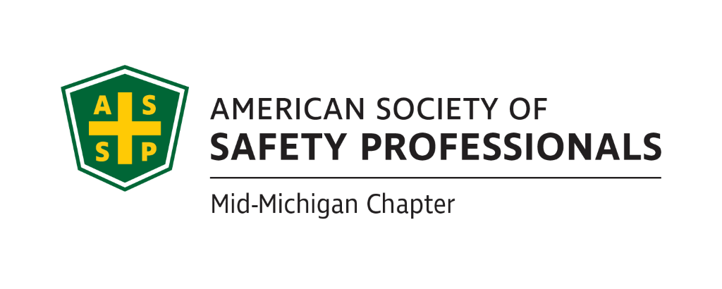
July Secretary Report
Meeting Date: July 13th, 2022
Meeting Time: 2:30-4:00pm
Format: WebEx
Attendees: Bob Schneider, Carl Granger, Craig Galecka and Bob Kirkby
Meeting started: 2:33pm
Meeting Ended: 3:45pm
June Secretary Report Review:
- Approved as written.
June Treasury Report Review:
- The only transaction to date in July is the ACH MPS billing of $29.90, which results in our current checking balance of $16,667.76.
- Savings remains at $100.
- Approved as written
Past Chapter Events and activities:

- No events to report for June.

Future Chapter Event updates:
- “Coffee with MIOSHA” .
  - Will be held at GLSTC August 23rd from 9-11
  - We will serve coffee and donuts.
  - Will need to provide a flyer for this
  - Chris Johnson is taking the lead on this
  - Will publicize at social at One North
  - Can request ASSP swag from Geri Golonka-ask for 100 so we have extra for future events.
- TBD: “Multi-Employer Worksite & Managing Contractors” –.Zach Hansmann
  - Will serve coffee and donuts.
  - Schedule around 12-1:30pm timeframe.
  - Craig sent Historical Museum dates of interest but hasn’t heard back yet, will follow up with a phone call.
- TBD: “Organizational Awareness” – Mike Snyder
  - No updates on this from last meeting.
  - Jeff talked with Great Lakes Safety Training Center and they are willing to allow us to use their facility for presentations. They are currently presenting some lockout/tagout training for which they have a grant, but that training may be too long. We will need to determine their availability based on their schedule. Jeff-will discuss next week and look to schedule in the fall.

- TBD: “Risk Management” (Jeff’s past presentation)
  - We need to determine when we can get this scheduled based on location availability and availability of the other presenter. Jeff can schedule in Sept or Nov. Could combine with Behavior Based Safety with Kelly, see below. GLST can host.
  - Possibility of combining “Drones” -see below, with this presentation as it ties in with Risk management.
  - Can we hold this at LASC or the Historical Museum or the Best Western if we decide to charge and provide CEUs for this event?
- TBD: “Behavior-Based Systems” –
  - We can use GLST.
  - No word on whether Kelly is available post retirement, Bob K will follow up before the next meeting.
- TBD: Tour of Michigan Sugar – Jeff
  - Can schedule in October. This could last 2 hours.
  - No update on this from last meeting.
- TBD: “First Aid training” –
  - Need to find a space maybe use the church James S. is affiliated with.
  - On hold due to Covid, could be scheduled in Fall.
  - Bob Kirkby won’t charge trainer fees but needs to cover AHA materials costs. But we would charge for the course around $85. Could use AGC building on Larch in the basement.
  - Carl will contact his contact at AGC for availability.
- TBD: “Drones: - Craig Galecka
  - Craig is available to present on Drones and the requirements for use. Can be a solo training or stand-alone training that would last 45 minutes. It can be remote or live.
- For CEUs, we must apply 5 weeks in advance but can be for a 1-hour presentation.
  - Should we try to look at more virtual meetings due to gas prices and lingering covid?
- Mary to contact James Gauthier for future virtual training offerings.
  - Yes James will have a few presentations for us. Will review for August meeting.

Ideas for Future Events:
- Food Safety issues with Linda Zuluski from Little Caesars from ASSP Detroit
- Discussion to schedule a social gathering for all the Mid-Michigan ASSP members for the meeting in July.
  - We discussed scheduling a gathering at Jackson Field for a Lugnuts game-due to the cost and the minimum required attendance of 30 people for the Pepsi Porch, the Lugnuts game is not a feasible location for the ASSP gathering.
  - Other options for the ASSP meeting would be to use a bar or restaurant with a patio. Mary to present possible options for the June meeting.
  - We cannot provide alcohol due to insurance coverage or lack thereof, attendees will have to purchase their own alcohol unless a vendor volunteers to provide alcohol.
  - Mary reviewed the restaurant options. We settled on One North.
  - We will offer light snacks, no alcohol.
  - Tentative Date for July 14th at 4:30-Mary to reserve.
  - We should ask members to register so they will RSVP so the map is included in the invite.? Contact support@assp.com through Mark. Bob Kirkby will look for a template. Maybe invite other chapter presidents?

- Could we use the Lansing Area Safety Council for this and other meetings? Bob K will contact LASC’s new director, Rita Lamoreaux and discuss a partnership. Bob K will follow up with her before next meeting.
- Bob S. mentioned the Upper Michigan Safety Conference-should we be participating in this since it’s in our footprint? We will put this on our calendar for next year’s meeting.
- Any questions about the Alliance paperwork Bob Schneider sent out? Chris Johnson tries to set up a monthly call to presidents of chapters. Do we want to extend more invitations to Chris Johnson? Invite him to our ASSP meetings and gathering. Ask Chris Johnson to review the Alliance requirements for us so we understand expectations.
- For COMT we get 400 quarterly points to review our website monthly. Need to add this as a recurring agenda item.
- Post meeting notes on our website each month to meet this requirement.
- Website needs updating
Social Media (Nathan):
- The group discussed whether we could drive more member engagement through Linkedin. Will follow up with Nathan

New Business:
- Replacement for James’ delegate position, Bob Kirkby will fill in
- Election update: congrats to all the re-elected.
- Nathan is still interested in maintaining the website
- Website photos need to be updated they are very old, members take photos when we are gathering.
- Need to review responsibilities for each position.
- Leadership conference-officers need to attend for COMT points-could be virtual or in Chicago.
- Bob Schneider. will submit the COMT report the deadline is coming up soon as well as the financial audit.
- We are currently looking at Gold status. Bob will set up a meeting so we are all aware of the topics that are important for the COMT.
Roundtable Discussion:
- Nothing to report for the roundtable discussion
- Mary Bainbridge
- Carl Granger
- Bob Kirkby
- Bob Schneider
Craig Galeka

Schedule for next meeting:

- August 17th, 2022 @ 2:30pm

