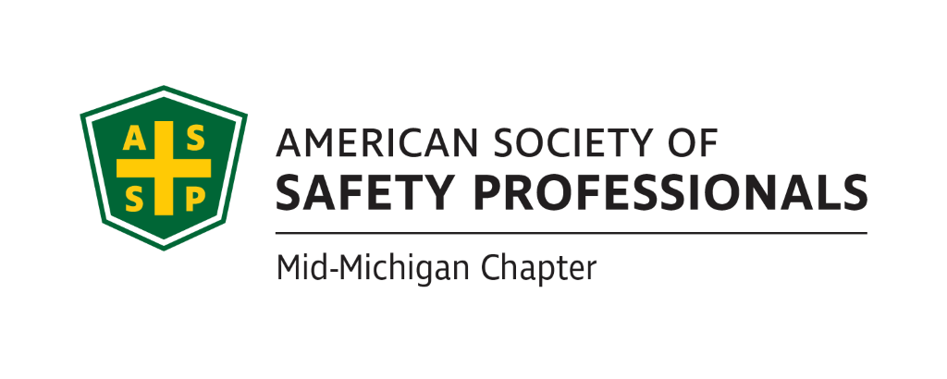
June Secretary Report
Meeting Date: June 15th, 2022
Meeting Time: 2:30-4:00pm
Format: WebEx
Attendees: Mary Bainbridge, Craig Galecka, Carl Granger, Jeff Gray, Robert Kirkby, Bob Schneider
Meeting started: 2:36pm
Meeting Ended: 3:28pm
June Secretary Report:
- March, April and May Secretary Reports were approved.
June Treasury Report:
- $17,512.56 final balance on account. The only revenue came from dues which were $1,828.50. Expenses totaled $722.19. Cash balance is $16797.66 for May.
- Carl reported that MSC booth sales are going to $270 from $170 which was covered by chapter presidents equally in the past. All MSC costs for vendors and attendees are increasing to cover the cost of hosting.
- March, April, May Treasurer reports approved by Board
Past Chapter Events and activities:

- Nothing events to report for June.

Future Chapter Event updates:
- TBD: “Coffee with MIOSHA” .
  - Great Lakes Safety Training Center (GLSTC) offered several dates in August: 4th, 9th, 23rd and the 30th.
  - Chris Johnson from MIOSHA says we don’t need to have the signing on the exact date of the 3 year anniversary. We can schedule date and then announce the signing at Coffee with MIOSHA.
  - Bob S. is waiting to hear back from CJ and the other chapters to see their availability, then we can pick a date.
  - Schedule from 9-11am. We will serve coffee and donuts.
- TBD: “Multi-Employer Worksite & Managing Contractors” –.Carl reported that Zac is still in but we need to get him some dates for the Historical Museum (HM) in Lansing. Craig said the HM is available we need to get them some dates-Craig to see what dates are open in August or September. We will serve coffee and donuts. Schedule around 12-1:30pm timeframe.
- TBD: “Organizational Awareness” – Mike Snyder Jeff talked with Great Lakes Safety Training Center and they are willing to allow us to use their facility for presentations. They are currently presenting some lockout/tagout training for which they have a grant, but that training may be too long. We will need to determine their availability based on their schedule. Jeff-will discuss next week and look to schedule in the fall.
- TBD: “Risk Management” (Jeff’s past presentation) We need to determine when we can get this scheduled based on location availability and availability of the other presenter. Jeff can schedule in Sept or Nov. Could combine with Behavior Based Safety with Kelly, see below. GLST can host.
- TBD: “Behavior-Based Systems” – Still looking for an optimal time with Kelly. Bob K noted Kelly just retired but she is still interested could combine with Jeff’s Risk Pres. We can use GLST.
- TBD: Tour of Michigan Sugar – Jeff can schedule in October. This could last 2 hours.
- TBD: “First Aid training” – Need to find a space maybe use the church James S. is affiliated with.
- TBD: “Drones: - Craig Galecka is available to present on Drones and the requirements for use. Can be a solo training or stand alone training that would last 45 minutes. It can be remote or live.
- For CEUs, we must apply 5 weeks in advance but can be for a 1 hour presentation.
- Should we try to look at more virtual meetings due to gas prices and lingering covid?
- Mary to contact James Gaulthier for future virtual training offerings.

Ideas for Future Events:
- Discussion to schedule a social gathering for all the Mid-Michigan ASSP members for the meeting in July.
  - We discussed scheduling a gathering at Jackson Field for a Lugnuts game-due to the cost and the minimum required attendance of 30 people for the Pepsi Porch, the Lugnuts game is not a feasible location for the ASSP gathering.
  - Other options for the ASSP meeting would be to use a bar or restaurant with a patio. Mary to present possible option for the June meeting.
  - We cannot provide alcohol due to insurance coverage or lack thereof, attendees will have to purchase their own alcohol unless a vendor volunteers to provide alcohol.
  - Mary reviewed the restaurant options. We settled on BJs Brewhouse.
  - We will offer light snacks, no alcohol.
  - Tentative Date for Bjs July 14th at 4:30-Mary to reserve.
  - We should ask members to register so they will RSVP so the map is included in the invite.? Contact support@assp.com through Mark. Bob k will look for a template. Maybe invite other chapter presidents?

- Could we use the Lansing Area Safety Council for this and other meetings? Bob K will contact LASC’s new director, Rita Lamoreaux and discuss a partnership. Bob K will follow up with her before next meeting.
- Bob S. mentioned the Upper Michigan Safety Conference-should we be participating in this since it’s in our footprint? We will put this on our calendar for next year’s meeting.
- Mary B. to inquire whether we can use Jackson facilities for meetings.
- Any questions about the Alliance paperwork Bob S sent out? CJ tries to set up a monthly call to presidents of chapters. Do we want to extend more invitations to CJ? Invite him to our ASSP meetings and gathering at BJs. Ask CJ to review the Alliance requirements for us so we understand expectations.
- For COMT we get 400 quarterly points to review our website monthly. Need to add this as a recurring agenda item.
- Post meeting notes on our website each month to meet this requirement.
- Website needs updating
Social Media (Nathan):
- The group discussed whether we could drive more member engagement through Linkedin. Will follow up with Nathan

New Business:

- Election update: congrats to all the re-elected.
- Nathan is still interested in maintaining the website
- Bob S. will submit the COMT report the deadline is coming up soon as well as the financial audit.
Roundtable Discussion:
- Nothing to report for the roundtable discussion
- Mary Bainbridge
- Carl Granger
- Bob Kirkby
- Bob Schneider
- Jeff Gray

Schedule for next meeting:

- July 13th, 2022 @ 2:30pm brief meeting

