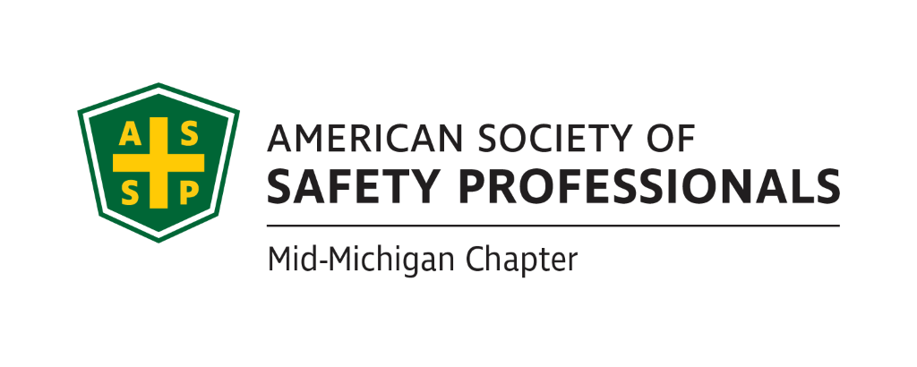
May Secretary Report
Meeting Date: May 18, 2022
Meeting Time: 2:30-4:00pm
Format: WebEx
Attendees: Mary Bainbridge, Carl Granger, Robert Kirkby, Bob Schneider
Meeting started: 2:33pm
Meeting Ended: 3:28pm
May Secretary Report:
- We were not able to review and approve the Secretary Report due to a lack of quorum.
May Treasury Report:
- We were not able to review and approve the Treasury Report due to a lack of quorum.
Past Chapter Events and activities:
- Nothing to report for May

Future Chapter Event updates:
- TBD: “Coffee with MIOSHA” Bob will check with Chris Johnson from MIOSHA to see if there is a possibility we can schedule this event in the Lansing area. We discussed reserving the Okemos Conference Center, where we have held several prior events.
- TBD: “Multi-Employer Worksite & Managing Contractors” – Craig wasn’t able to speak to Zac Hansmann at the Michigan Safety Conference but he will contact him through email or phone.
- TBD: “Organizational Awareness” – Mike Snyder Jeff talked with Great Lakes Safety Training Center and they are willing to allow us to use their facility for presentations. They are currently presenting some lockout/tagout training for which they have a grant, but that training may be too long. We will need to determine their availability based on their schedule.
- TBD: “Risk Management” (Jeff’s past presentation) We need to determine when we can get this scheduled based on location availability and availability of the other presenter.
- TBD: “Behavior-Based Systems” – Still looking for an optimal time with Kelly.
- TBD: Tour of Michigan Sugar – Did not discuss this training, it is on hold.
- TBD: “First Aid training” – Did not discuss this training, on hold
- TBD: “Drones: - Craig Galecka is available to present on Drones and the requirements for use.

Ideas for Future Events:
- Discussion to schedule a social gathering for all the Mid-Michigan ASSP members for the meeting in July.
  - We discussed scheduling a gathering at Jackson Field for a Lugnuts game-due to the cost and the minimum required attendance of 30 people for the Pepsi Porch, the Lugnuts game is not a feasible location for the ASSP gathering.
  - Other options for the ASSP meeting would be to use a bar or restaurant with a patio. Mary to present possible option for the June meeting.
  - We cannot provide alcohol due to insurance coverage or lack thereof, attendees will have to purchase their own alcohol unless a vendor volunteers to provide alcohol.
- Coffee with MIOSHA-Chris Johnson recommended Great Lakes Safety Training Center for the Alliance signing.
  - Concerns about other chapters (Detroit and West Michigan) driving to Midland. One solution would be to send ask them if this location is acceptable for them.
  - Could we use the Lansing Area Safety Council for this and other meetings? Bob K will contact LASC’s new director, Rita Lamoreaux and discuss a partnership.
- Bob S. mentioned the Upper Michigan Safety Conference-should we be participating in this since it’s in our footprint?
- Mary B. to inquire whether we can use Jackson facilities for meetings.

Social Media (Nathan):
- The group discussed whether we could drive more member engagement through Linkedin. Will follow up with Nathan

New Business:

- No new business to report.
Roundtable Discussion:
- Nothing to report for the roundtable discussion
- Mary Bainbridge
- Carl Granger
- Bob Kirkby
- Bob Schneider

Schedule for next meeting:

- June 15th, 2022 @ 2:30pm

