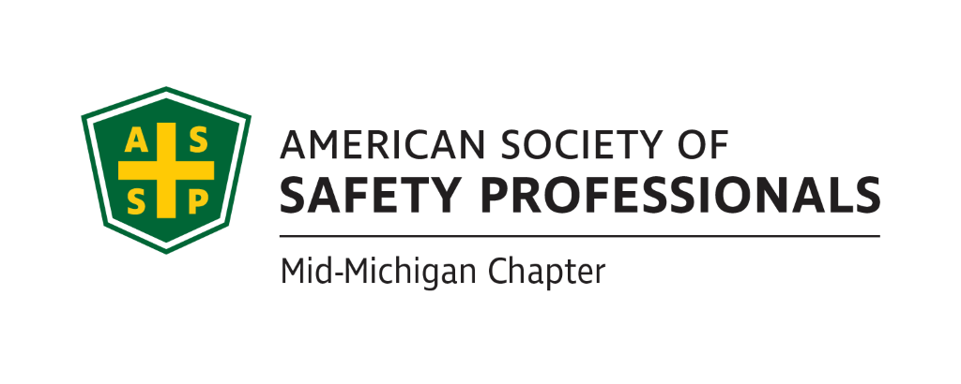
Secretary Report
Meeting Date: April 20, 2022 2:30pm - 4:00pm
Meeting Time: 2:30-4:00pm
Format: WebEx
Attendees: Carl Granger, Jeff Gray, Craig Galecka, Bob Schneider, James Stokes
Meeting started: 2:30pm
Meeting Ended: 4:00pm
Secretary Report: March Secretary report was not approved as presented due to unprofessional language, format, and lack of clarity.
Treasurer Report: March Treasury Report was not approved as presented.
  - Craig will update it and send it to us for a vote during the next meeting.
  - We also spoke about the annual requirements for the COMT. Craig and Bob will review what is required, which may be due by the end of the month.
Review of Items from Prior Meeting:
  - Craig reported that the Library and Historical Center just needs dates and they are open to us using their facility.

Past Chapter Events and activities:
April 12, 2022: Michigan All-Chapter Meeting at the Michigan Safety Conference.
- The group agreed that the speaker Jason Russel was very good and there was good attendance.
- Bob will check with the other two chapters to see about sending the speaker some ASSP swag or even a thank you.
Future Chapter Event updates:
- TBD: “Coffee with MIOSHA” Bob will check with Chris Johnson from MIOSHA to see if there is a possibility we can schedule this event in the Lansing area. We discussed reserving the Okemos Conference Center, where we have held several prior events.
- TBD: “Multi-Employer Worksite & Managing Contractors” – Craig wasn’t able to speak to Zac Hansmann at the Michigan Safety Conference but he will contact him through email or phone.
- TBD: “Organizational Awareness” – Mike Snyder Jeff talked with Great Lakes Safety Training Center and they are willing to allow us to use their facility for presentations. They are currently presenting some lockout/tagout training for which they have a grant, but that training may be too long. We will need to determine their availability based on their schedule.
- TBD: “Risk Management” (Jeff’s past presentation) We need to determine when we can get this scheduled based on location availability and availability of the other presenter.
- TBD: “Behavior-Based Systems” – To be determined, Bob S. will discuss with Bob K.
- TBD: Tour of Michigan Sugar – Did not discuss this training, it is on hold.
- TBD: “First Aid training” – Did not discuss this training, on hold
- TBD: “Drones: - Craig Galecka is available to present on Drones and the requirements for use.

Ideas for Future Events:
- Discussion to schedule a social gathering for all the Mid-Michigan ASSP members for the meeting in July.
- We discussed scheduling a gathering at Jackson Field for a Lugnuts game.
- James will reach out to Jackson Field to get more details on pricing. James noted that since we had the ROC there, they have contacted him several times for future reservations.

Survey Results (Nathan):
Discuss survey results we received.
- Nathan was not present at this meeting, no discussion of the survey at this time.

House of Delegates updates (James):
James Stokes, Delegate provided an overview of the voting details:
- Selling Society office: 179 voted yes, 9 no, 3 abstained
- HOD revised bylaws: 117 yes, 68 no, 6 abstained

New Business:

- ROC meeting in West Virginia.
  - We discussed and Bob S. will be attending. Our bylaws allow us to send someone without getting Board approval for expenses. Bob reviewed his plans and he would keep the Board aware of his projected costs.
  - Email for “Open Call For Volunteers”
  - There was an email sent that gave a good example we could use to send to the chapter members to get them engaged in volunteering for our chapter.

Roundtable Discussion:
Nothing to report for the roundtable discussion
- Carl Granger
- Bob Schneider
- Craig Galecka
- Jeff Gray
- James Stokes

Schedule of next meeting:

- May 18th, 2022 @ 2:30pm

