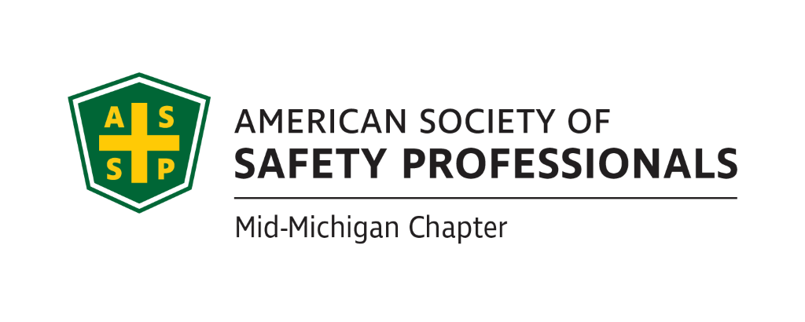
Secretary Report-Revised for Approval
Meeting Date: March 16, 2022 2:30pm - 4:00pm
Meeting Time: 2:30-4:00pm
Format: WebEx
Attendees: Carl Granger, Bob Schneider, Bob Kirkby, Craig Galecka, Mary Bainbridge
Meeting started: 2:33pm
Meeting Ended: 3:55pm
February Secretary Report: Secretary Report approved as presented
February Treasurer Report: Treasury Report was approved as presented.
Review of Items from Prior Meeting:

- The Chapter is investigating why the monthly credit card processing fees increased. The Chapter will review the paperwork that was signed when the account was set up. We will also research what other chapters are using for collecting fees from members for events. This issue will be presented at the next President’s meeting to determine if there are any solutions.
- Jeff Gray will work on possible dates with Mike Snyder (Decra Process Safety Management consultant) on the “Organizational Awareness” presentation.
- Carl will check on possible locations for the Coffee with MIOSHA. Baker College in Jackson for Alliance signing. This is tentative at this time.
- Bob Schneider will contact Chris Johnson from MIOSHA about locations and dates for Coffee with MIOSHA. We are also looking into the Alliance signing- Chris from MIOSHA is waiting for a location from the Chapter and a date as well. This is also tentative at this time.
- Bob Schneider will confer with Nathan about revising the survey to include surveying members about the ASSP selling the building in Illinois. Only one or two people responded to the survey out of 130.

Past Chapter Events and activities:
- Virtual Chemistry Safety presented by Kathy Malone- March 9th , 2022.

Future Chapter Event updates:
- MSC (April): “Oxford School Shooting” – Jason Russell
- TBD: “Coffee with MIOSHA” March is taken and now OSHA is looking at the summer of 2022.
- TBD: “Multi-Employer Worksite & Managing Contractors” – Zac Hansmann Craig is working with the Historical museum to see if there is a space in May or June or later.
- TBD: “Organizational Awareness” – Mike Snyder
- TBD: “Risk Management” (Jeff’s past presentation)
- April 25th could be a potential month for this training. Potential location at GLSTC. A suggestion was made to offer CEUs to increase attendance. Application for offering CEU’s must go out a month in advance. Craig could present Drone Training and Application Requirements at the same time to meet GLSTC’s hosting requirements. See below for substituting Bob K presentation
- TBD: “Behavior-Based Systems” – Bob Kirkby is researching. Possible coordination with Jeff’s risk presentation at GLSTC April 25th and Craig would schedule drones separately. Bob is checking with Kelly from GLSTC to see if this will work.
- TBD: Tour of Michigan Sugar – Jeff Gray-Tentative for later in the year as long as gatherings are safe due to Covid
- TBD: “First Aid training” – Bob Kirkby-Contingent on Covid levels and the safety of gathering in groups. and where to hold the event.
- TBD: “Drones: - Craig Galecka-See Risk Management and Behavior-Based training above.

Ideas for Future Events:
- Discussion to schedule a social gathering for all the ASSP members for the meeting in July.
- We would need to establish a “not to exceed” amount for approval for a place holder so the Chapter doesn’t have to go back for every single expense. The Chapter will revisit this at the next meeting. We might need to reserve a pavilion.
- Mary to investigate City Limits in Mason’s options. Apparently, they can hold 30 people in a banquet room. Mary to verify if there is a fee to use the room with fewer than 30 attendees. Mary to find out the name of the other bar by the Lansing City Market. If we have a vendor present at the meeting, the Chapter rules allow the vendor to pick up the alcohol tab.
- Carl to research the Jackson Field for a Lugnuts game and whether we can reserve a room.

Survey Results (Nathan):
Discuss survey results we received.
- Nathan was not present at this meeting, no discussion of the survey at this time.

House of Delegates updates (James):
- James Stokes submitted his vote. He supported the governance and HOD changes and the sale of the ASSP building.

- HOD meetings
- Governance change vote
- Society building sale

New Business:
- Bob will update the Board on the Presidents meeting and will pass along any information from his notes.
- ROC in West Virginia this year May 4th-6th-Bob is checking to see if he can go or will send a proxy.
- A Tennessee chapter is in the process of being sunsetted due to low membership.
- Safety 2022 in Chicago
- Bob is sending Chet a gift card
- For the Michigan Safety Conference, we need volunteers to tend the booth. To sign up to tend the booth, see the google document from the West Michigan ASSP chapter (Rich Deleau).

Roundtable Discussion:
Nothing to report for the roundtable discussion
- Carl Granger
- Bob Schneider
- Craig Galecka
- Mary Bainbridge
- Bob Kirkby

Schedule of next meeting:

- April 20th, 2022 @ 2:30pm

