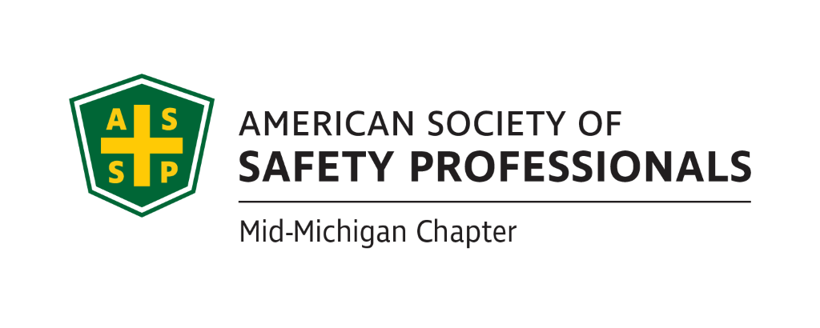
Secretary Report
Meeting Date: February 16, 2022 2:30pm - 4:00pm
Meeting Time: 2:30-4:00pm
Format: WebEx
Attendees: Carl Granger, Bob Schneider, Jeff Gray, Mary Bainbridge
January Secretary Report: Mary will send the minutes from the January meeting in a Secretary Report for approval. The Secretary Report from 2-16-22 was send out on 3/16/22 to the Board.
Treasurer Report: Craig’s Treasury Report was approved as presented.
Review of Items from Prior Meeting:

- Craig Galecka will check to see why the monthly credit card processing fees went up:
Bob is wondering if we should just stop the credit card if we can’t get this resolved. We bought a credit processing chip and we believe that will only work with that credit card. Should we hold on as in-person meetings may get started back up in summer. Still need to figure out why charge went from $10 to$30.
- Jeff Gray will work on dates with Mike Snyder (Decra process safety mgmt consultant) on the “Organizational Awareness” presentation. (Will likely be February or April) In process-nothing to report at this time.
- Carl will check on possible locations for the Coffee with MIOSHA. Still waiting for a response
- Bob Schneider will get with Chris Johnson from MIOSHA about locations and dates for Coffee with MIOSHA. Will work for summertime our alliance is due and it would be nice if we could coordinate the “coffee” with alliance signing in August.
- Bob Schneider will get with Nathan about revising the survey to include ASSP selling the building. Nathan added 2 questions to survey and resent survey, we don’t know the results yet.

- Bob Schneider will resend the revised survey and information on the governance changes.
- Bob Schneider will check with Jeff on a chapter tour to Michigan Sugar, “Organizational Awareness” presentation, and “Risk Management” presentation. MS still not allowing any non essential visitors due to Covid. Not sure if it will be open around beet season, but maybe need to look around August for scheduling.

- Nathan to post James Gauthier’s presentation on the chapter website. We think Nathan is following up on this-he has the presentation.

- Bob Schneider will check with the McKinley Ohio chapter to see if the presenter of “Fire Protection Systems” would be willing to present for our chapter. The presenter was not willing to work outside of Ohio. Will keep eyes open for other training opportunities for virtual sprinkler and FPS training.

- Bob Schneider will send out a communication for SPY nominations. We did not have SPY nominations this year.

Past Chapter Events and activities: None

Future Chapter Event updates:
  - March 9, 2022: “Virtual Chemistry Safety” – Kathy Malone May need to check to see if it went out to all in email. Bob S. will check to see what happened with notification.
  - MSC (April): “Oxford School Shooting” – Jason Russell
  - TBD: “Coffee with MIOSHA” March is taken and now OSHA is looking at the summer of 2022.
  - TBD: “Multi-Employer Worksite & Managing Contractors” – Zac Hansmann Use the Historical Society for this pres?
  - TBD: “Organizational Awareness” – Mike Snyder
  - TBD: “Risk Management” (Jeff’s past presentation) Week of April 25th could be a potential time for this training. Mid morning at GLSTC? Should we schedule another topic to draw more people? Bob will reach out to Craig to see if he has a presentation for this. Jeff could see if GLSTC could present LOTO training. Maybe we can offer CEUs to draw people? Application for offering CEU’s must go out a month in advance.
  - TBD: “Behavior-Based Systems” – Bob Kirkby is researching.
  - TBD: Tour of Michigan Sugar – Jeff Gray
  - TBD: “First Aid training” – Bob Kirkby
  - TBD: “Drones: - Craig Galecka

Ideas for Future Events:
Should we schedule a social meeting for all the ASSP members? Sometime around July? Most agreed to put something on the calendar. Maybe somewhere outdoors? We would need to do a “not to exceed” amount for approval for a place holder so you don’t have to go back for every single expense. Will revisit at next meeting. We might need to reserve a pavilion. Mary will check to see if we can reserve an outside area at City Limits for 20-40 people in August-how will that work?

Survey Results (Nathan):
Discuss survey results we received. Nathan was not present at this meeting.

House of Delegates updates (James):
Bob to follow up with James before his vote.
  - HOD meetings
  - Governance change vote
  - Society building sale

ASSP Governance change and selling the Society building:
Board members on this call agree.
  - What is the Board and chapter’s position?

New Business:
- Is getting more chapter members connected on our LinkedIn page a way to get more member involvement?
- Make sure we really use our Linkedin page to generate more membership.

Roundtable Discussion:
  - Carl Granger
  - Bob Schneider
  - Jeff Gray
  - Mary Bainbridge

Schedule of next meeting.

March 16th, 2022 @ 2:30pm

