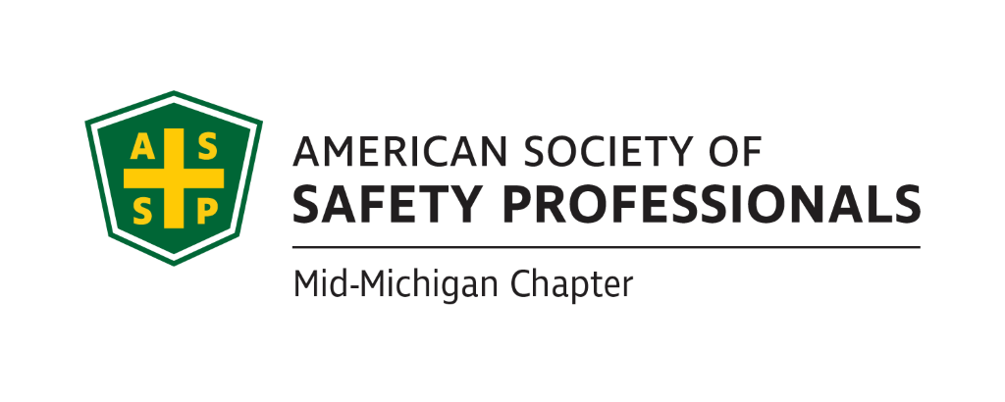
Meeting Agenda – Wednesday, December 15, 2021 2:30pm - 4:00pm
Via WebEx – please see calendar request for log-in information
present: Carl Granger, Bob Schneider, Jeff Gray, Nathan Fawcett, Mary Bainbridge,
- Review Secretary Report approved

- Review Treasurer Report

- Takeaways from the prior meeting:
  - Craig Galecka will check to see why the monthly credit card processing fees went up. He will also follow up on another communication from the bank about additional charges we could incur.
  - Jeff Gray will work on dates with Mike Snyder on the Organizational Awareness presentation.
  - Monthly or quarterly newsletter.
  - Bob Schneider send out survey and information on the governance changes.
  - Nathan will check with Chapter Web Services about making the “join” button on our website more visible.
  - Develop a chapter blog to assist our members with questions and challenges. We discussed the Mid-Michigan LinkedIn site. Nathan said he is posting current events posters, etc and will continue to update the site. Possible Q1 initiative. Carl said trades group is moving all their content to social media and seems the community is weary of social media right now. It’s hard to get participation. Table for now. Nathan not sure what the process is when messages are posted on the site, should he contact someone in the chapter to respond? Not sure how to get more traffic. Carl-yes please do forward posts to the chapter members so we can find answers. Bob-asked Nathan how many members are on our linkedin? 20. Are they all mid mich assp? Yes plus some previous members. Survey questions includes asking for email address, what would add value to you? Are there any topics you would like to see covered in the future? Bob- we can try to send Linkedin link whenever we send out any communications to drive traffic.
  - Bob Schneider will check with James about using the church on MLK.Not a venue we can use right now they’re not open
  - Carl Granger will check with AGC to see if they would be willing to offer a room for Bob Kirkby to conduct First Aid training. Carl said they are open for us to use check back after the holiday
- Past Chapter events and activities:
  - December 3: ASSP Region 7 President’s call.Bob-talked about governance and how members would vote, most supported the change. Nominations committee for Region 7, RVP role open. Salina, Mark and John(?) on nom committee. Discussed OSHA mandate in 6th circuit, have decided to go with 3 panel judges.
  - December 3: Michigan ASSP OSHA Alliance call. Bob talked about possible topics for workplace violence for joint meeting. Security division is also going to be speaking about workplace violence issues all day long so maybe too much overlap? Will need more details about the speaker before we make a decision so it’s not redundant.

- Future Chapter event updates:
  - December 15: “Risks of Disinfection – What Can Go Wrong” – James Gauthier Miosha asked for recording of this. Need to send materials out to attendees.
  - December 20: “Home Ergonomics” – Mary Bainbridge
  - TBD: “Error Proofing for Fatigue and Other Cognitive Challenges” – Kathy Malone Carl will send out email to see if January is an option to present
  - TBD: “Coffee with MIOSHA” March is taken and now OSHA is looking at the summer of 2022. Chris Johnson is checking to see when we can schedule for our chapter. What venues were we going to use for this? Carl is checking to see if Cobblestone farms in AA and Jackson an outside venue which would be good for summer.
  - Late Fall/Early Winter: Old Nation Brewery Food Tour
  - TBD: “Multi-Employer Worksite & Managing Contractors” – Zac Hansmann possible location is the historical building in Lansing. Still on hold for live presentations. Table until January
  - TBD: “Organizational Awareness” – Mike Snyder
  - TBD: “Risk Management” (Jeff’s past presentation)Follow up with Jeff to see when he can do this?
  - TBD: “Behavior-Based Systems” – Bob Kirkby is researching.
  - TBD: Tour of Michigan Sugar – Jeff Gray
  - TBD: Bill Sims presentation for $2500 – Carl Granger Possible to split with other chapters on cost Carl has not heard back yet.
  - TBD: “First Aid training” – Bob Kirkby

- Ideas for future events:
  - None at this time

- ASSP Governance changes:
  - Send out survey Is there a question on the survey on the assp changes? Yes. Do we need to resend another survey out on this issue since it’s already been covered? No not on it’s own but we can include the survey with all assp communications.
  - What is the Board’s position?

- New Business:
- Should we send out gift certificate to speaker Jim Gauthier? $30 gift certificate. Bob to check with Craig to see how we can send him a gift card.
- Roundtable:
  - Carl Granger
  - Bob Kirkby
  - James Stokes
  - Craig Galecka
  - Bob Schneider
  - Jeff Gray
  - Nathan Fawcett
  - Mary Bainbridge
  - Brian Oczepek

- Schedule the next meeting.

January 19th, 2022 @ 2:30pm Date will work

