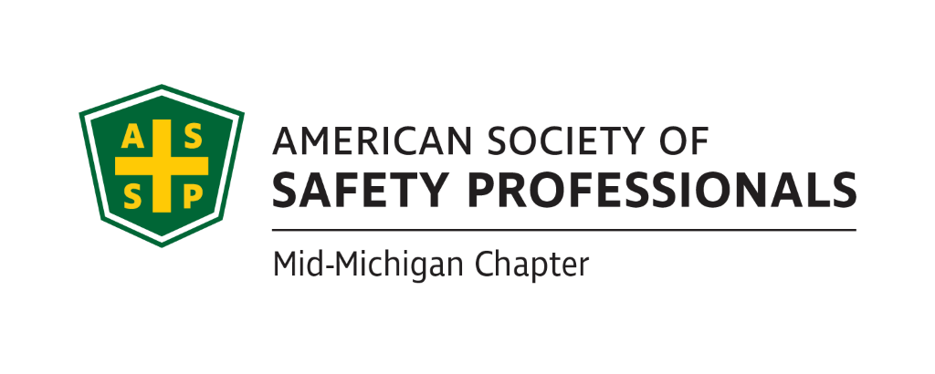
Meeting Agenda – Wednesday, November 3, 2021 2:30pm - 4:00pm
Via WebEx – please see calendar request for log-in information
Attendees: Carl Granger, Robert Kirkby, Bob Schneider, Jeff Gray, Mary Bainbridge
Meeting started at 2:35pm
Red=existing notes
Blue=Mary’s notes
- Review Secretary Report
Adjustment to notes-Carl-CMU program isn’t big enough to have a student section so it’s not viable
- Secretary report approved

- Review Treasurer Report

Savings=$100

Checking $16725.81

$166.75=income from dues

Payment to ACH MPS billing =$29.90

We need to get with World Pay not 5/3 is charging that fee not resolved but have to follow up
Treasurer’s report approved

- Takeaways from the prior meeting:
  - Craig will check to see why the monthly credit card processing fees went up. He will also follow up on another communication from the bank about additional charges we could incur.
  - Take Carl’s name off the bank account and add Bob. (Completed)
  - Craig will check the MI Library and Historical Center to see if they will be open in January for the All Chapters Coffee with MIOSHA. (This is an option we just need to contact them per Craig, then Carl noted that MIOSHA per Chris Johnson doesn’t want to have Coffee in Lansing since they already have one scheduled. We could look into Ann Arbor or another city outside of Lansing. Still need to find a location)
  - Craig will check with Old Nation Brewery for a possible holiday party in December.
  - Carl will check with Zac Hansmann from MSU about a presentation for Multi-Employer Worksite and Managing Contractors. Zach prefers in person look into January for dates
  - Jeff will check with Mike Snyder on the Organizational Awareness presentation. Look into after the first of the year, he is willing to do this. Jeff will work on dates.
  - Monthly or quarterly newsletter. Anyone interested in volunteering speak up
  - Student chapter with Central Michigan University. Could do a lunch and learn – could do it virtually and send them pizzas. We need a faculty member to support. See above, this is not an option.
  - Reach out to each member to personally engage them to be more active. What about a survey? Tie it into the governance email. Nathan sent out a test survey
  - Enhance our website. Will need to check once per quarter. Maybe put a join button – already on there but not visible. Nathan will check with Mark.
  - What else? Look for potential future leaders. How can we solve member’s problems when they come up such as ask a question – like a blog. ASSP Mid-Michigan Chapter LinkedIn – most of us forgot about it.

- Past Chapter events and activities:
  - House Of Delegates Caucus
  - Region VII Member Town Hall: September 20, 2021
  - House Of Delegates Meeting: September 28, 2021
  - Leadership Conference: October 21 – 22, 2021
  - Fall ROC meeting
Carl, the changes they want to make means they won’t need the house of delegates anymore.
Bob-participated in region 7, town hall, HOD meeting, ROC (pres of assp discussed the governance change. A few dissenting opinions related to the governance change)
Reach out for Leadership conference recordings-Mary.
James will be voting on behalf of the chapter.
- Future Chapter event updates:
  - TBD - November: “Home Ergonomics” – Mary Bainbridge 45 minute presentation Mary will provide dates the week after thanksgiving-November 30th ish. Mary will create a flyer for the training.
  - TBD – December or early next year: “Error Proofing for Fatigue and Other Cognitive Challenges” – Kathy Malone Carl check with Kahy’s availability for a time for a virtual meeting in December or maybe next year
  - March: Coffee With MIOSHA need to schedule in Ann Arbor Cobblestone Farms-they will supply coffee and donuts maybe, or Jackson (see if chamber of commerce has suggestions for a location) Carl will follow up.
  - TBD: “All Chapters Coffee With MIOSHA” – Chris Johnson (Will be virtual or at the Historical Society Museum.) See above
  - Late Fall/Early Winter: Old Nation Brewery Food Tour Chapter provide food for all members but not booze. Depends on Covid status, may need to wait until spring. Consensus is to hold off until after the first of the year.
  - TBD: “Multi-Employer Worksite & Managing Contractors” – Zac Hansmann
  - TBD – October: “Organizational Awareness-high reliability orgs” – Mike Snyder Jeff said after the first of the year will start working with him once we know which month to look at scheduling. Feb and April are open, Jeff will confirm which month and date.
  - December: Holiday Party (Brookshire Inn or library.
  - Hazards Of Sanitation Mary provides dates in December before Christmas when James Gaulthier can present.
  - WELL Health & Safety Certification Too costly -off table
  - Risk Management (Jeff’s past presentation) Can Jeff present this again? Yes just let him know when.
- Ideas for future events.
Bob K-behavior based safety system from company that is involved in wells and fracking.
Jeff-Tour of sugar making process scheduled after Covid
Carl-Bill Simms (greenbeans and ice cream) offered to perform virtual pres on greenbeans or HOP for $2500. Could share costs between 3 chapters. Jeff asked if he can present live right after the safety conference? To offset cost we could charge attendance.
Bob K-offer CPR/AED first aid certification from AHA for $75 per person. Bob would waive his instructor fee. Class size can be 10-15 people. Charging this amount is right in line with other providers. Venues? Lansing Area Safety Center, AGC, Church option (Bob will check with James).

- ASSP Governance changes:
  - Send out survey Bob will follow up with Nathan
  - What is the Board’s position?

- New Business:
- No new business
- Roundtable

- Schedule the next meeting.
December 15th in afternoon around 2:30
Meeting was adjourned at 3:40pm

